Led Display 12V Battery Low Voltage cut off On Switch Excessive Protection Board
2.5 out of 5 stars8 product ratings
About this
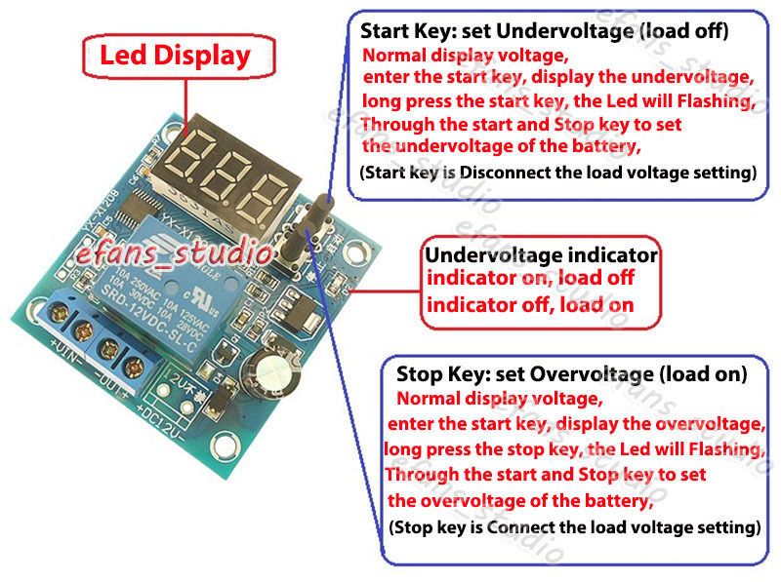

Product Identifiers
- GTIN
0953880219522
- UPC
0953880219522
- eBay Product ID (ePID)
2172810313

Product Key Features
- Nominal Voltage Rating (DC)
12 V
- Protection Properties
Low Voltage Protection
- Nominal Current Rating
10 A

Dimensions
- Item Height
50*48*20mm/1.96*1.89*0.78"
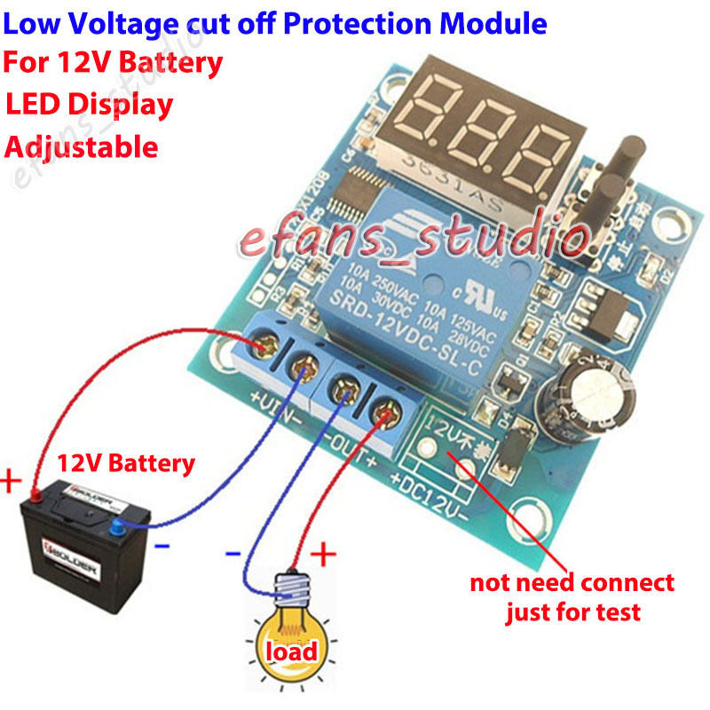
For example: 12V battery set under voltage (the load cut off voltage) is 10.5V,
When the voltage is to 10.5V or below 10.5V, This controller board delay 6 second then cut off the load.
if the voltage is rise and over 10.5V within 6 second, the load will not cut off and keep turn on.
The overvoltage(the load turn on voltage) can set between 10.6V-15V, you can set it according your charger volatge
or using voltage to set it.

Press the start and stop key together, the LED will display 888, that mean reset the controller successful.

does not offer proper protection
relay is off when powering load relay turns on when voltage goes low and isolated load but because relay is still powered the battery will drain down and when voltage to low to hold relay in the relay turns off and load is repowered from flat battery
Verified purchase: Yes | Condition: New

